**Medford public schools**

**The center for citizenship and social responsibility**

**Symposium on Addiction**

**Proactive Steps and resources**

**Recommended audience: Parents and Teachers of k-8 students (open to all)**

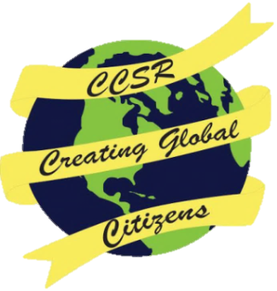

Saturday, April 2nd, 12:45 PM.- 5:00 PM. at Medford High School

Admission is free and refreshments will be served

Admission is free and refreshments will be served

**Keynote Speaker: Clinical Psychologist, Dr. Robert Brooks**

***Topic: Raising Resilient Children and Adolescents***

***For more information go to drrobertbrooks.com***

***“Raising Resilient Children and Adolescents***

Limited Seating- Reserve your spot now on the Medford Public School Website

Limited Child Care is Available - Registration is required. Please call Marie Cassidy at (781) 393-2106 by March 28th

Workshops

* *What Parents and Teachers Can Do About Substance Abuse: In the Home and Classroom*
* *Preventative Family Strategies*
* *Identifying Substances*
* *Identifying Signs & Symptoms of Anxiety and Depression in Adolescents*
* *Anxiety and Depression: How Substance Abuse Impacts Young Children*

Contact, Michael Skorker at mskorker@medford.k12.ma.us

Resource fair to follow all workshops

*This event is made possible by a grant from Bloomberg Philanthropies*